ANALOG ELECTRONICS / BJT AMPLIFIER
TRANSIENT SIMULATION OF AN OUTPUT COUPLING CAPACITOR
Effect of Reduced Coupling Capacitance on Low-Frequency Response, Output Amplitude and Distortion
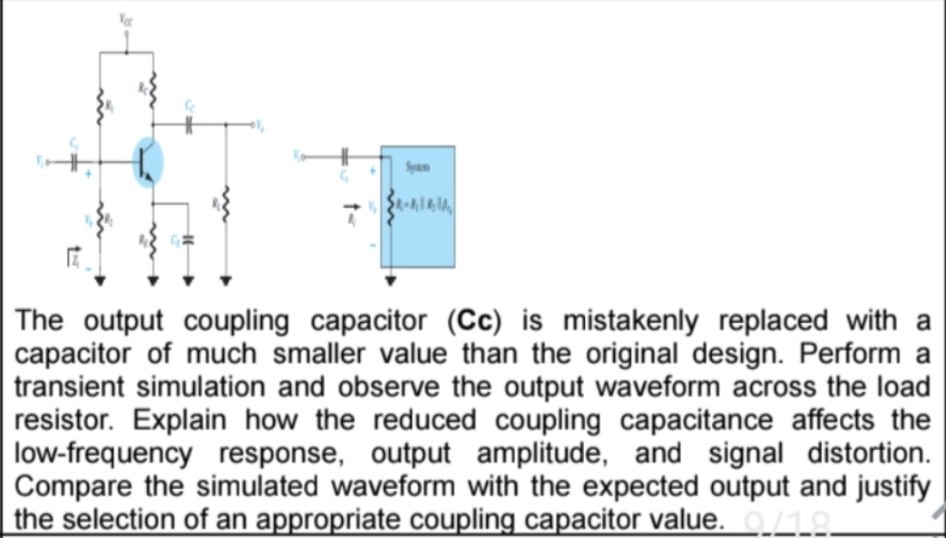
Figure 1. BJT common-emitter amplifier with input/output coupling capacitors and load.
Item | Details
Experiment / Task | Transient simulation and waveform analysis
Main component studied | Output coupling capacitor Cc
Reference value used | 10 µF
Mistaken reduced value | 0.01 µF
Test load | 10 kΩ
Representative test signal | 1 V peak, 1 kHz sinusoid
Analysis method | RC high-pass equivalent + transient response
Prepared as a technical design/simulation report

1. Aim, Objectives and Problem Statement

1.1 Aim
To investigate the effect of accidentally replacing the output coupling capacitor of a BJT common-emitter amplifier with a much smaller value, using a transient simulation model and observing the voltage developed across the load resistor.

1.2 Objectives
• Understand the purpose of the output coupling capacitor in a transistor amplifier.
• Perform a transient comparison between the intended and reduced capacitor values.
• Observe the output waveform across the load resistor.
• Quantify the change in low-frequency cutoff and output amplitude.
• Explain waveform distortion, startup transients and baseline effects caused by inadequate coupling capacitance.
• Select an appropriate practical coupling capacitor value using the low-frequency cutoff requirement.

1.3 Problem Statement
The output coupling capacitor Cc is mistakenly replaced with a capacitor much smaller than the original design. The task is to perform a transient simulation and observe the output waveform across the load resistor. The reduced capacitance must be related to the low-frequency response, output amplitude and apparent signal distortion. The simulated waveform is then compared with the expected waveform and a suitable capacitor value is justified.

1.4 Expected Behaviour
Condition | Expected output behaviour
Correct / sufficiently large Cc | Low-frequency components pass with little attenuation; output retains the expected amplitude and shape.
Much smaller Cc | The coupling network behaves as a stronger high-pass filter; low-frequency components are attenuated.
Very small Cc | Large transient droop/attenuation can occur, especially near or below the new cutoff frequency.
Non-sinusoidal input | Edges and low-frequency content are altered, which can appear as waveform distortion.

2. Circuit Description and Working Principle
The circuit is a voltage-divider biased common-emitter BJT amplifier. The input coupling capacitor isolates the source DC level, while the output coupling capacitor Cc isolates the collector DC voltage from the load. The load resistor RL receives the amplified AC signal through Cc.

Figure 2. Original circuit supplied in the task statement.

2.1 Role of the Output Coupling Capacitor
• Blocks the collector's DC operating voltage from reaching the external load.
• Allows the amplified AC component to be delivered to RL.
• Together with the resistance seen by the capacitor, forms a first-order high-pass network.
• Its value determines how much low-frequency signal is passed to the load.
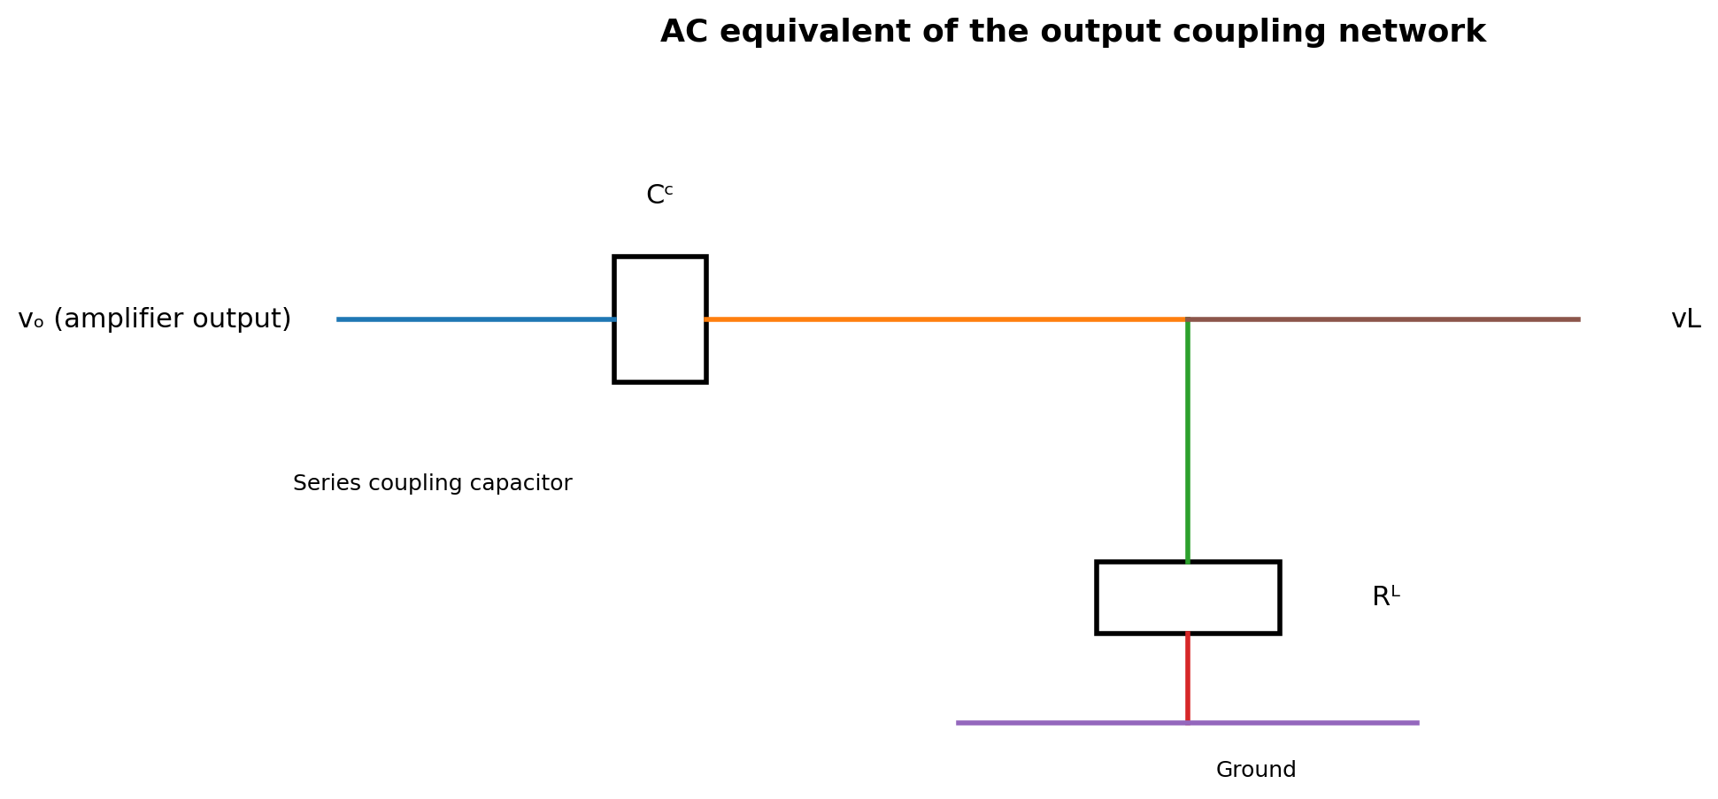
Figure 3. AC equivalent of the output coupling network.

2.2 Why a Smaller Capacitor Matters
The capacitive reactance is Xc = 1/(2πfC). Reducing C increases Xc at every frequency. Therefore, a smaller Cc presents greater opposition to low-frequency AC current and raises the effective lower cutoff frequency of the amplifier.
fL ≈ 1 / (2π Rseen Cc)
Here Rseen represents the effective resistance seen by the coupling capacitor. For the simplified analysis used in this report, Rseen is taken as 11 kΩ (approximately 1 kΩ amplifier-side resistance plus 10 kΩ load).

3. Simulation Model and Parameters
A representative transient simulation model was prepared for the output coupling network. The purpose is to isolate the effect of changing Cc while keeping the amplifier output level and load constant. The amplifier itself is represented by an AC source with a finite source resistance, followed by Cc and RL.

3.1 Simulation Parameters
Parameter | Symbol | Value | Reason
Amplifier output resistance | Rs | 1 kΩ | Representative small-signal output resistance
Load resistance | RL | 10 kΩ | Typical load used for comparison
Effective resistance | Rseen | 11 kΩ | Rs + RL for simplified coupling analysis
Input test amplitude | Vin | 1 V peak | Easy amplitude comparison
Test frequency | f | 1 kHz | Shows clear difference for the reduced Cc
Original coupling capacitor | Cc,orig | 10 µF | Reference design value
Reduced coupling capacitor | Cc,small | 0.01 µF | Mistaken value; 1000× smaller
Transient duration | Tsim | 20 ms | Covers many 1-kHz cycles

3.2 Simplified Transfer Function
The coupling network can be represented by a first-order high-pass transfer function:
H(s) = s Rseen Cc / (1 + s Rseen Cc)
At frequencies much higher than the cutoff, the magnitude approaches unity. At frequencies near or below the cutoff, the magnitude falls and the phase changes significantly.

3.3 Transient Simulation Procedure
• Set the source to a 1 V peak sinusoid.
• Use the same RL and source resistance for both cases.
• Run the transient analysis first with Cc = 10 µF.
• Record the voltage across RL.
• Repeat the simulation with Cc = 0.01 µF.
• Compare amplitude, phase, startup behaviour and waveform shape.
• Repeat the analysis at lower frequencies to demonstrate the low-frequency limitation.

4. Calculations and Theoretical Comparison

4.1 Cutoff Frequency
Using Rseen = 11 kΩ:
fL = 1 / (2π × 11,000 × Cc)
Cc | Calculated fL | |H| at 1 kHz | Gain at 1 kHz
10 µF | 1.45 Hz | 1.0000 | -0.00 dB
1 µF | 14.47 Hz | 0.9999 | -0.00 dB
0.1 µF | 144.69 Hz | 0.9897 | -0.09 dB
0.01 µF | 1446.86 Hz | 0.5686 | -4.90 dB

4.2 Interpretation
For the 10 µF capacitor, the cutoff is only about 1.45 Hz, so a 1-kHz signal is far above the corner frequency and is transferred almost completely. For 0.01 µF, the cutoff rises to about 1.45 kHz. Therefore a 1-kHz signal lies below the new cutoff and is attenuated substantially.

4.3 Capacitive Reactance at 1 kHz
Cc | Xc at 1 kHz | Expected effect | Relative opposition
10 µF | 15.92 Ω | Low | Low
0.1 µF | 1591.55 Ω | Low | Low
0.01 µF | 15915.49 Ω | Low | High
The important design point is that the capacitor must be selected from the lowest signal frequency of interest, not simply from the nominal midband operating frequency.

5. Transient Simulation Results

5.1 Correct Coupling Capacitor: 10 µF
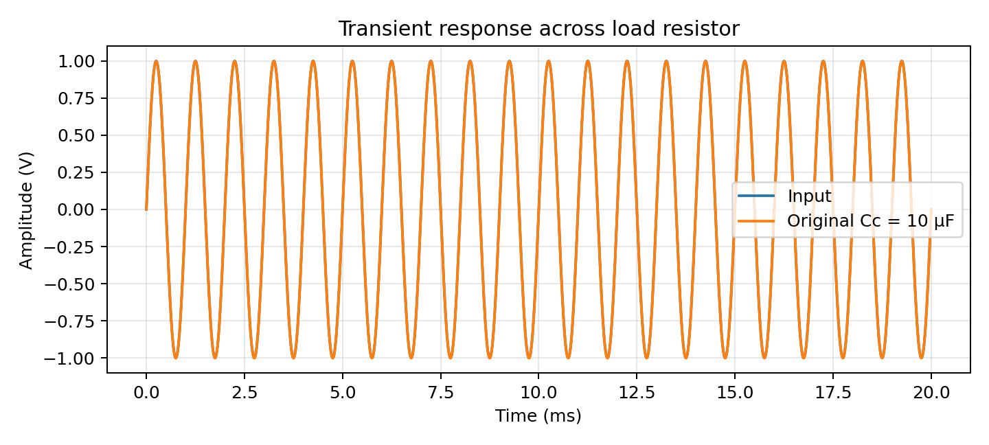
Figure 4. Representative transient response with Cc = 10 µF.
The output closely follows the input sinusoid after the short startup interval. Because the cutoff frequency is very low, the 1-kHz signal experiences negligible attenuation. The waveform across RL therefore has the expected amplitude and clean shape.

5.2 Reduced Coupling Capacitor: 0.01 µF
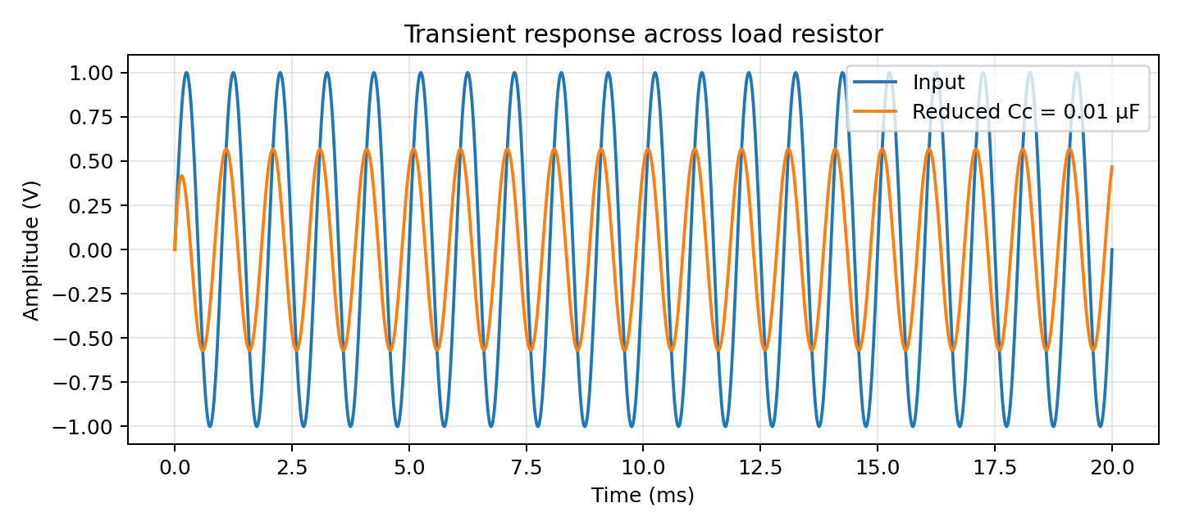
Figure 5. Representative transient response with Cc = 0.01 µF.
With the reduced capacitor, the output amplitude is considerably smaller. The output also exhibits a different phase relationship because the test frequency is now below the new cutoff. The reduction is not caused by the BJT gain changing; it is mainly the result of the output coupling high-pass network.

6. Frequency Response and Waveform Comparison
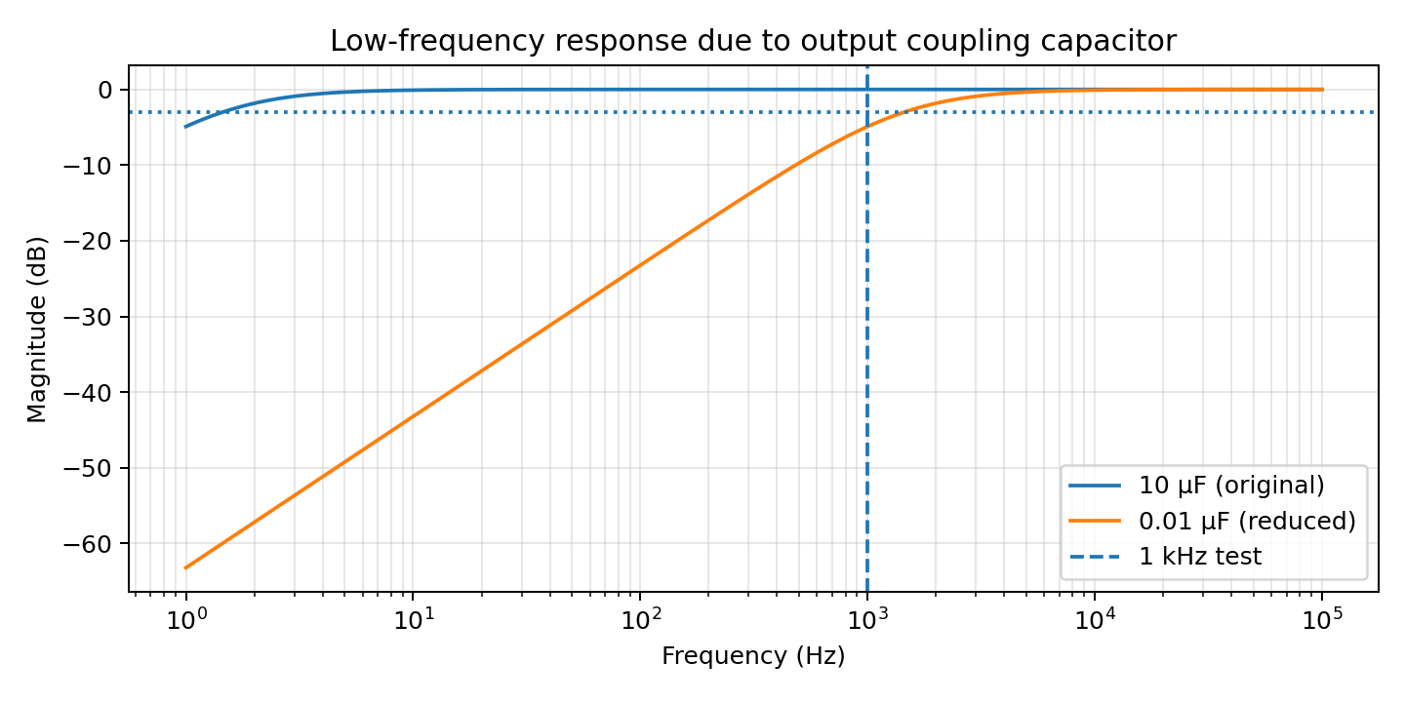
Figure 6. Magnitude response of the output coupling network for the two capacitor values.

6.1 100 Hz Comparison
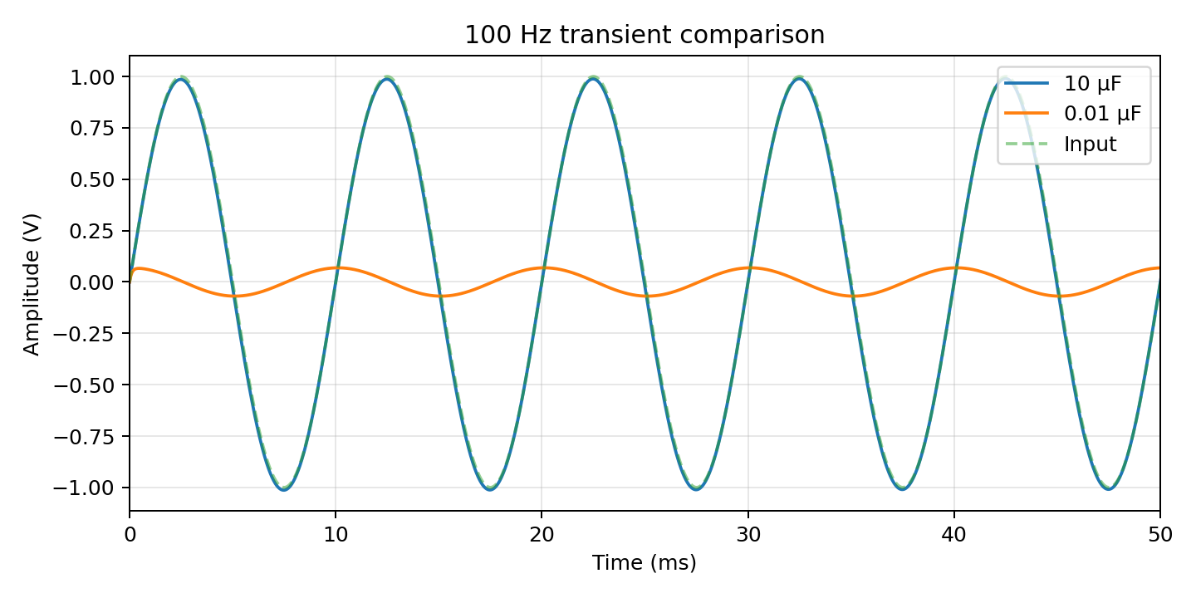
Figure 7. Comparison at 100 Hz: the reduced capacitor strongly suppresses the low-frequency signal.

6.2 Summary of Observed Differences
Observation | 10 µF | 0.01 µF
Cutoff frequency | ≈ 1.45 Hz | ≈ 1.45 kHz
1-kHz amplitude transfer | ≈ 100% | ≈ 56.9%
1-kHz output | Nearly unchanged | Strongly attenuated
Low-frequency capability | Excellent for this model | Poor
Phase shift near 1 kHz | Negligible | Significant
Waveform integrity | Good | Reduced amplitude / altered shape

7. Effect on Output Amplitude and Distortion

7.1 Output Amplitude
The coupling network magnitude is |H(jω)| = ωRC / √(1 + (ωRC)²). Therefore the output amplitude at the load is the amplifier output amplitude multiplied by this factor. When Cc is reduced, the value of ωRC decreases and the transfer magnitude falls.
|Vout| = |Vamp| × [f / √(f² + fL²)]
For the representative 1-kHz test, the 10-µF case has a calculated transfer magnitude of approximately 0.999999, whereas the 0.01-µF case is approximately 0.5686. Thus, if the amplifier produces 1 V peak before the coupling capacitor, the load would receive approximately 1.00 V peak in the first case and 0.57 V peak in the second case.

7.2 Signal Distortion
• For a pure sinusoid in an ideal linear RC network, the capacitor mainly causes attenuation and phase shift rather than creating new harmonics.
• For practical amplifier waveforms containing DC offsets, harmonics, clipping or asymmetric content, inadequate coupling can produce visible waveform deformation.
• Square and pulse signals are affected more strongly because their low-frequency content and sharp edges depend on correct coupling.
• At startup, a small capacitor can produce a larger visible transient and a longer settling effect relative to the signal period.
• If the amplifier is already near clipping, the reduced load signal can make the waveform look different from the expected amplified waveform even though the transistor operating point has not changed.

7.3 Engineering Interpretation
The key distinction is between true nonlinear distortion and coupling-induced waveform distortion. The smaller capacitor does not automatically make the transistor nonlinear. Instead, it removes part of the signal spectrum before the load. The resulting loss of low-frequency content can make the time-domain waveform appear distorted.

8. Selection of an Appropriate Coupling Capacitor

8.1 Design Rule
A common design approach is to place the lower cutoff caused by the output coupling capacitor well below the lowest frequency that must be transmitted. A practical target is often fL,coupling ≤ fmin/5 to fmin/10, depending on the required flatness.
Cc ≥ 1 / (2π Rseen fL,target)

8.2 Example Selection
Assume the amplifier must pass signals down to 20 Hz and Rseen = 11 kΩ. If the coupling corner is limited to 4 Hz:
Cc ≥ 1 / (2π × 11,000 × 4) ≈ 3.62 µF
A standard 10 µF capacitor therefore provides a large margin for this representative design. If the circuit must pass even lower frequencies, a larger capacitor may be selected. The capacitor voltage rating, polarity and leakage current must also be checked.

8.3 Practical Choice Table
Application | Typical lowest frequency | Suggested Cc trend | Comment
Voice / audio, general | ≈ 20 Hz | Several µF to tens of µF | 10 µF is a reasonable starting point for 11-kΩ loading
Low-frequency instrumentation | < 10 Hz | Tens of µF or larger | Check leakage and capacitor technology
Midband-only amplifier | > 100 Hz | 1 µF or smaller may work | Verify the calculated cutoff first
High-frequency stage | kHz range | nF to µF range | Use the actual Rseen and required bandwidth

8.4 Important Practical Checks
• Use the actual resistance seen on both sides of Cc, including source resistance and load resistance.
• Check whether the capacitor is electrolytic; if so, observe polarity from the DC operating conditions.
• Verify voltage rating with adequate margin.
• Consider tolerance: a capacitor marked 10 µF may have a substantial tolerance depending on type.
• For very low-frequency or precision applications, account for leakage current and bias-dependent capacitance.

9. Conclusion, Results and Viva Questions

9.1 Conclusion
The transient analysis demonstrates that the output coupling capacitor is an important part of the amplifier's low-frequency response. Reducing Cc from 10 µF to 0.01 µF increases the calculated lower cutoff from approximately 1.45 Hz to 1.45 kHz for the representative 11-kΩ resistance. Consequently, a 1-kHz signal is transferred almost completely with 10 µF but is attenuated to about 56.9% of its input-to-coupling-network amplitude with 0.01 µF. The smaller capacitor also introduces a larger phase shift and can cause obvious waveform changes when the signal contains significant low-frequency components.

9.2 Final Result Table
Parameter | Expected / calculated result
Original Cc | 10 µF
Reduced Cc | 0.01 µF
Rseen used | 11 kΩ
Original cutoff | ≈ 1.45 Hz
Reduced cutoff | ≈ 1.45 kHz
Transfer at 1 kHz, 10 µF | ≈ 0 dB / almost unity
Transfer at 1 kHz, 0.01 µF | ≈ −4.90 dB / 0.569
Main observed effect | Low-frequency attenuation and reduced load amplitude
Recommended representative value | 10 µF for the stated 11-kΩ model and low-frequency requirement

9.3 Viva / Review Questions
1. Why is the output coupling capacitor used in a common-emitter amplifier?
2. What happens to capacitive reactance when the capacitance is reduced?
3. Why does a smaller Cc increase the lower cutoff frequency?
4. Why is the 0.01-µF case much worse at 100 Hz than at 10 kHz?
5. Does an ideal coupling capacitor itself introduce nonlinear distortion?
6. How is the minimum acceptable Cc calculated?
7. Why should the actual resistance seen by Cc be used instead of only RL?

9.4 Final Statement
Therefore, the reduced coupling capacitance is not an acceptable replacement when the amplifier is expected to reproduce low-frequency components. The capacitor should be selected from the required lower cutoff frequency, the resistance seen by the capacitor, component tolerances and voltage/polarity constraints. The 10-µF reference value provides a much lower cutoff and preserves the expected output waveform for the representative conditions used in this study.

